Applications of .NET
Using .NET Framework, we offered to develop the following types of applications.
- Console Applications

- These applications contains similar user interface to the operating systems like MS-DOS and UNIX.
- Known as C.U.I (Character User Interface) applications.
- These are similar to C/C++ applications.
- These are smaller in size.
- Doesn’t contain any graphical features like mouse pointer, colors, fonts, buttons etc.
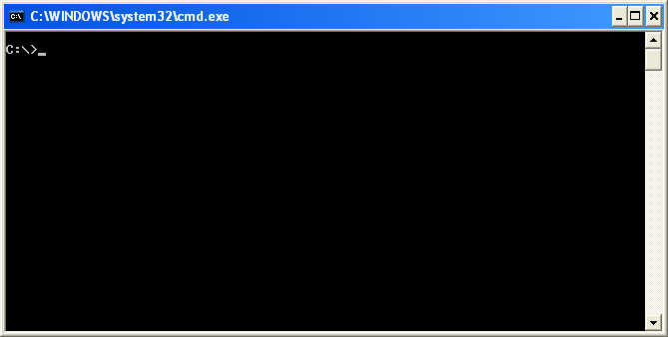

- Windows Applications
- These applications are designed similar to the “Windows” operating system.
- Known as G.U.I (Graphical User Interface) applications.
- Offers graphical features like mouse pointer, colors, fonts, buttons, text boxes etc.
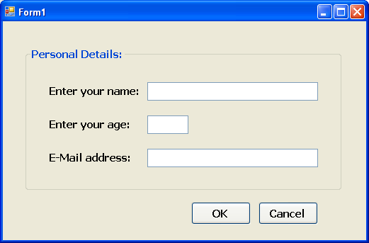

- Windows Services
- A Windows service is a long-running executable application.
- These can run only on windows platforms.
- These perform specific functions as background process.
- Doesn’t contain user interface or doesn’t require any user interaction.
- Windows services can be configured to start when the operating system is booted and run in the background as long as Windows is running, or they can be started manually when required.
- Examples:
    - Windows Time.
    - Windows Audio.
    - Anti-Virus Security.
    - Database services like Sql Server, My Sql and Oracle etc.
    - IIS State Services.
    - Battery Power Supply Status on Laptops.
etc.
- To see the all the installed windows services on the system, click on “Start” – “Control Panel” – “Administrative Tools” – “Services”.
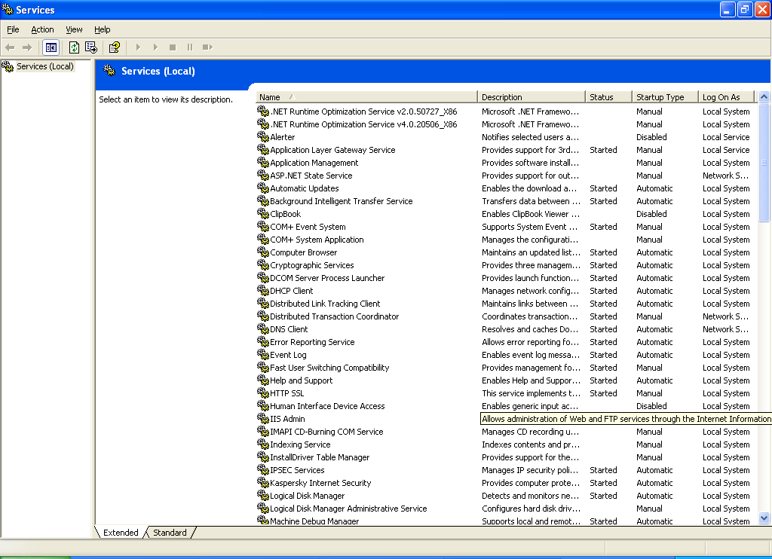
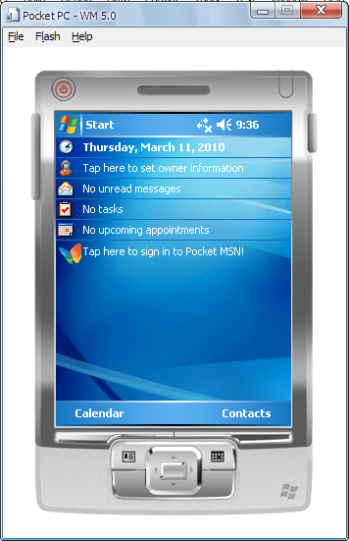
- Windows Mobile Applications
- The Mobile applications can run on the small devices like Pocket PCs, Smart phones and mobile devices.
- Ex: Mobile based calculators, schedulers, database manipulation applications etc.

- Web Sites / Web Applications
- These are most frequently used applications by every internet literature.
- In modern life every business (commercial) / educational / service oriented organizations are having their own web sites.
- Some other web sites are offering general purpose services that can be used by anybody like E-Mail, Search Engines, and Blogs etc.
- So, there is much demand for these applications in modern software development industry.
- In .NET Framework, the web sites can be developed using the technology called ASP.NET.
- Ex:
    - http://www.yahoo.com/
    - http://www.google.co.in/
    - http://www.orkut.com/
    - http://www.hotmail.com/


- Web Services
- Web Services are simple and easy to understand.
- These can be developed using again ASP.NET.
- These are also known as “web applications” similar to “web sites”. But Web sites expose certain user interface (in the form of web pages) to the end-user; Web services expose a certain programming logic which can be accessed through another web site.
- Examples:
    - Online shopping requires credit card authentication.
    - www.way2sms.com accesses the mail services of Yahoo and Gmail.

What we need to learn .NET
To get started with .NET Programming, the programmer must have previous knowledge in the following languages.

- C
(For Procedural Programming Experience)
- C++ (or) OOP Knowledge
(For Object Oriented Programming Experience)
- SQL
(For db queries)
- HTML
(For web page designing)

Before .NET

Branches of Microsoft Programming:

In the late 1990s, Windows programming using the Microsoft platform had divided into a number of branches.

  - Most programmers were using Visual Basic (VB).
  - Some other programmers were using Visual C++ (VC++) with MFC (Microsoft Foundational Classes).
  - The remaining programmers were using C or C++ in a combination with raw Win32 API.

Difficulties and Limitations:

All of these technologies had their own problems and difficulties.

- The raw Win32 API was not object-oriented, doesn’t supports a full-pledged graphical application because of limited libraries.
- MFC was object-oriented, but was inconsistent and getting old and it is very much complex in actual coding.
- There is no a perfect platform independent language.
- There is no easier mobile based application development language.

Promises by Microsoft:

While introducing .NET Framework, Microsoft Corporation given a promise to the software industry to deliver a standard Framework which overcomes the old problems and along with following:

- Multiple platforms: The system runs on a broad range of computers, from servers and desktop machines, smart phones and cell phones.
- Industry standards: The system uses industry standard communication protocols, such as XML, HTTP, SOAP, and WSDL.
- Security: The system can provide a much safer execution environment, which can’t be hacked or robbed by others.

